**Analysis Of Amazon Cell Phone Reviews Using Ibm Cloud**

An Internship Project Report

Submitted By

(BATCH NO: CSE_AIML_D08)

T.SUHARSHA(18481A05L4)

T.SOWMYA(18481A05K8)

CH.SAI KRISHNA (17481A0528)

**INDEX**

**TOPICS           PAGE NO**

**CHAPTER 1: INTRODUCTION 3**

1. OVERVIEW
2. PURPOSE

**CHAPTER 2: LITERATURE SURVEY 4**

1. EXISTING PROBLEM
2. PROPOSED SOLUTION

**CHAPTER 3: THEORTICAL ANALYSIS 5-6**

3.1 BLOCK DIAGRAM 5

          3.2 HARDWARE/SOFTWARE DESIGNING 5-6

**CHAPTER 4: EXPERIMENTAL INVESTIGATIONS 6**

**CHAPTER 5: FLOW CHART 7**

**CHAPTER 6: RESULTS 8**

**CHAPTER 7: ADVANTAGES AND DISADVANTAGES 8-9**

**CHAPTER 8: APLLICATIONS 9**

**CHAPTER 9: CONCLUSION 9**

**CHAPTER 10: FUTURE SCOPE 10**

**CHAPTER 11: BIBILOGRAPHY 10**

**CHAPTER12: APPENDIX 10-14**

12.1 Source code 10-11

12.2 Output screenshots 11-14

**CHAPTER 1**

**INTRODUCTION**

**1.1 Overview:**

Mobile phones have revolutionized the way we purchase products online, making all the information available at our fingertips. Reviews and ratings submitted by consumers became an integral part of the customer’s buying decision process. The review and rating platform provided by eCommerce players creates a transparent system for consumers to take decisions and feel confident about it.

However, it is difficult to read all the feedback for a particular item especially for the popular items with many comments. In this project, we will attempt to understand the factors that contribute to classifying reviews as positive or negative

We will be using Natural language processing to analyze the sentiment (positive or a negative) of the given review. A sample web application is integrated to the model built.

**1.2 Purpose:**

Amazon cell phone reviews is finding the opinion from a large data which helps to analyze which review is positive and which is negative and based on that we can analyse and improve the our product.

**CHAPTER 2**

**LITERATURE SURVEY**

**2.1** **Existing Problem:**

As cellphone is the new revolution,most of the people are using this for all purposes.But before few years,we use to buy product based on some Tv ads or by the suggestions of seller.

But we know the influence of ads,which is not real and not even the opinion of seller.So nowa days influence of cellphone has a huge impact on our lives.

**2.2 Proposed Solution:**

So by use of cellphone and various online shopping sites,customers if they want to buy some product ,then they are first checking the reviews given by other customers who bought them.So based on the most of reviews the customer who wants to buy is deciding whether to buy a product or not.

So we have to analyse the reviews of the product using natural language processing and deciding whther it is a positive or negative review.

**CHAPTER 3**

**THEORTICAL ANALYSIS**

**3.1 Block Diagram:**

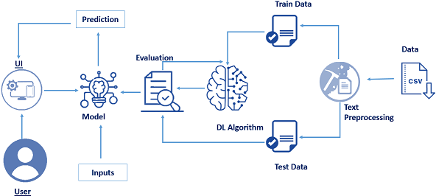

**3.2 Hardware/software designing:**

**Software specifications:**

|  |  |
| --- | --- |
| **REQUIREMENT** | **SPECIFICATIONS** |
| Anaconda Navigator | Anaconda Navigator is a free and open-source distribution of the Python and R programming languages for data science and machine learning related applications. It can be installed on Windows, Linux, and macOS. |
| Python | The version required to run this project is 3.7 0r 3.8 to install libraries. |
| numpy | The version required is 1.19.5 |
| pandas | pandas is a software library written for the Python programming language for data manipulation and analysis.The version required is 1.3.0. |
| tensorflow | TensorFlow provides a collection of workflows to develop and train models using Python.The version required is 2.5.0. |
| flask | The version is required is 2.0.1 |
| keras | The version is required is 2.5.0 |

**Hardware Specifications:**

Processor-i3

RAM-1.5GB

**CHAPTER 4**

**EXPERIMENTAL INVESTIGATIONS**

In the contemporary world,people share their thoughts rapidly in social media.Now a days large no.of reviews posted by the viewers on the web provide valuable information to other people.

Such information is highly essential for decision making and hence popular among the internet users.

**CHAPTER 5**

**FLOW CHART**

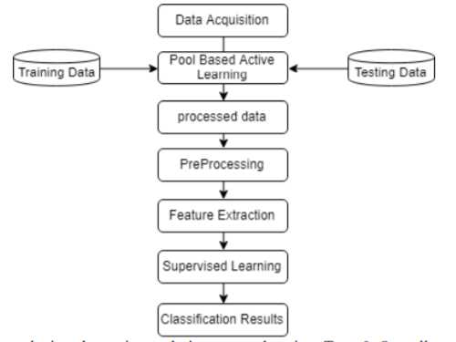

**CHAPTER 6**

**RESULTS**

* The user gives the input values from theUI interface which is created by flask application
* The user inputs are given to th AI which consists of the machine learning model.
* This model performs the data pre-processing and sentiment analysis using text-preprocessing on the given input values predicts the output.
* The output will be send to flask application using an http request and displays it to the user.

**CHAPTER 7**

**ADVANTAGES AND DISADVANTAGES**

**Advantages:**

* We will be able to know the customers opinion about product.
* We will know about various modifications to be done to product.
* By reading reviews it will encourage other customers to buy our mobile.
* Inexpensive Way to  Improve Your Products and Services
* Measure Customer Satisfaction
* Create Best Customer Experience
* Reliable Source of Information About Other Competitors
* Reduce Cost and Time Constraints

**Disadvantages:**

* Chances of Customer Dissatisfaction
* Concerns About Privacy
* The writing can misguide you from actuality

**CHAPTER 8**

**APLLICATIONS**

**The areas where this solution can be applied:**

* Query performance
* Aggregate view of data vs transactional view
* Normalized databases are typically tuned for simple queries
* Product analysis
* Social media monitoring
* Customer feedback

**CHAPTER 9**

**CONCLUSION**

Amazon’s product review platform shows that most of the reviewers have given 4-star and 3-star ratings to unlocked mobile phones. We also uncovered that lengthier reviews tend to be more helpful and there is a positive correlation between price & rating. Review analysis shows that positive review is prevalent among the reviews and in terms of emotions, ‘trust’, ‘anticipation’ and ‘joy’ have highest scores.

We can also look at building a model to predict the helpfulness of the review and the rating based on the review text. There are many more insights to be unveiled from the Amazon reviews.

**CHAPTER 10**

**FUTURE SCOPE**

Some future works which can be included to improve the model and also to make it more effective in practical cases. Our future works include applying PCA (Principal Component Analysis) in active learning process to fully automate data labeling process with less assistance from the oracle. The model can be incorporate with programs that can interact with customer seeking a score of a particular product. As we used a large scale dataset we can apply the model on local market sites to get better accuracy and usability. And lastly we will try to continue this research until we generalize this model to all kinds of text based reviews and comments

**CHAPTER 11**

**BIBILOGRAPHY**

References of previous works or websites visited/books referred for analysis about the project, previous solution findings etc.

<file:///C:/Users/HP/Downloads/FSentimentAnalysisonLargeScaleAmazonProductReview.pdf>

**CHAPTER 12**

**APPENDIX**

**12.1 Source code**

* Data Collection.
  + Collect the dataset or Create the dataset
* Text Preprocessing.
  + Import the Libraries.
  + Importing the dataset.
  + Remove Punctuations
  + Convert each word into a lower case.
  + Stemming.
  + Splitting Data into Train and Test.
* Model Building
  + Import the model building Libraries
  + Initializing the model
  + Adding Input Layer
  + Adding Hidden Layer
  + Adding Output Layer
  + Configure the Learning Process
  + Training and testing the model
  + Optimize the Model
  + Save the Model
* Application Building
* Create an HTML file
* Build a Python Code

**12.2 Output screenshots**

**Review:**THE PHONE IS GOOD

GOT IT AS POSITIVE TWEET.

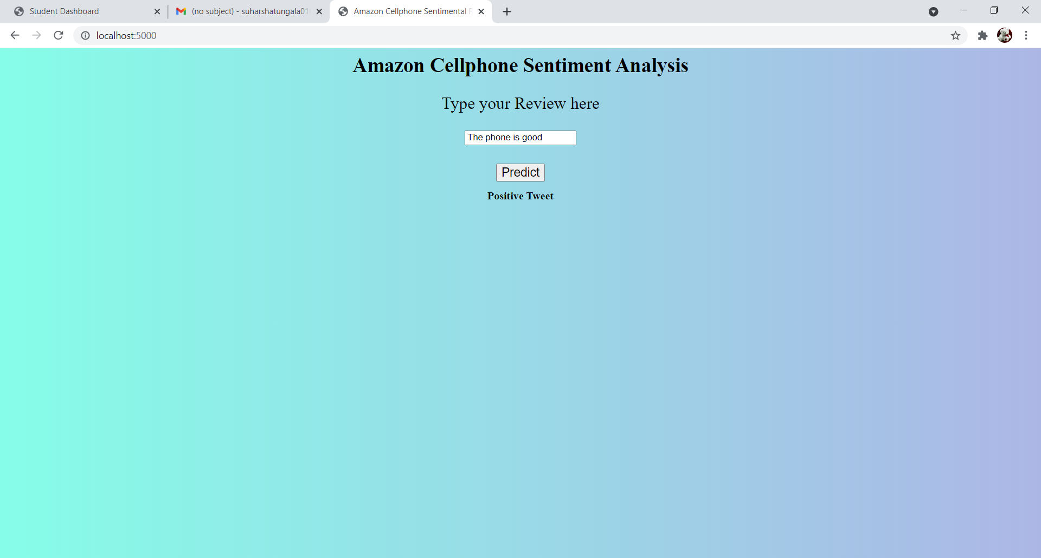

**Review:** I was disappointed with the phone's battery

IT HAS GIVEN AS A NEGATIVE TWEET

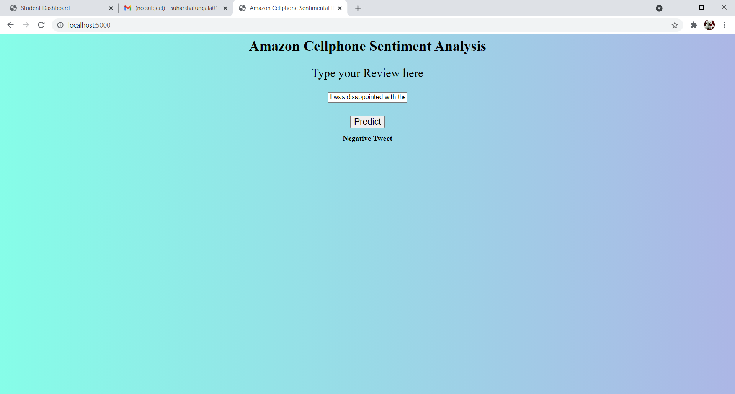

**REVIEW:**fantastic

IT IS GIVEN AS THE POSITIVE TWEET.

